|  |  |
| --- | --- |
| No. of Pages | **7** |
| No. of Questions | 7 |

**Department of Computer Science and Engineering**

**FINAL EXAMINATION SPRING 2017**

**CSE490/EEE453: WAN Routing and Technologies**

**Total Marks:100 Time Allowed: 2.5 Hours**

* Answer any **FIVE (5)** questions out of the given **SEVEN(7)** questions.
* Figure in bracket [] next to each question indicates marks for that question.

###### Question No. 1

1. What are the conditions that must be same for Ether Channel to work? [3 marks]
2. Two switches are running LACP. Which modes of LACP on both sides of two ports of each switch will not establish ether channels? [2 marks]
3. What are the common places where syslog messages are being saved? [3 marks]



**Figure No. 1**

1. Refer to figure no. 1, Explain the syslog message in terms of mnemonic, timestamp, description, facility and severity level. [4 marks]

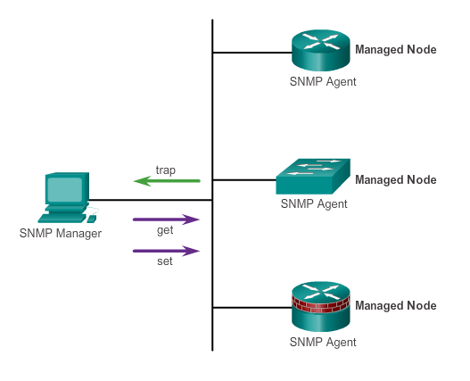

**Figure No. 2**

1. What are the purpose of using get-request and set-request messages in SNMP ? [4 marks]
2. How does TRAP messages in SNMPv3 help reduce the disadvantages of periodic polling? [4 marks]

Question No. 2

1. What are the parameters that are negotiated during LCP link establishment? What will happen if the routers do agree on some parameters? [5 marks]

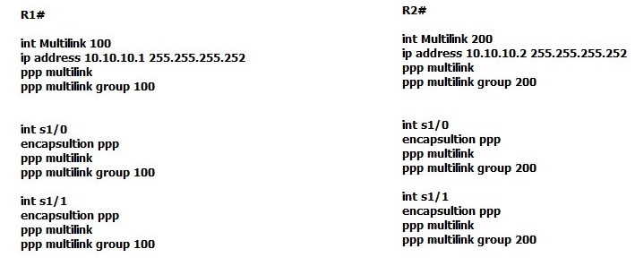

**Figure No. 3**

1. Refer to the commands above in figure no.3 . What is being implemented here in Router R1 and R2? [4 marks]
2. How and why do PPP check or monitor the link between routers? [3 marks]

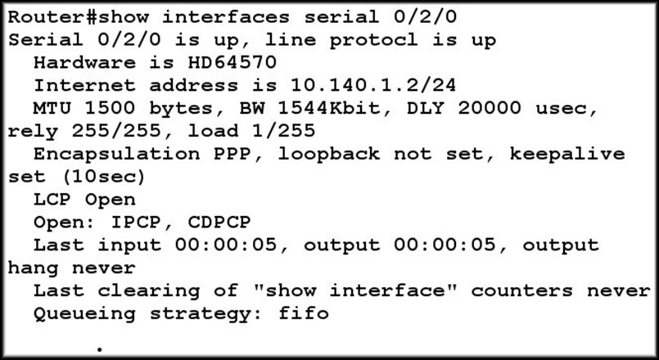

**Figure No. 4**

1. Referring to the output shown above in figure no. 4, explain the part circled. What do the two lines imply? [4 marks]

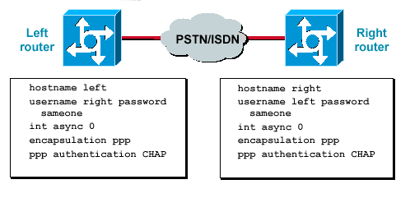

**Figure No. 5**

1. Refer to the output shown in figure no. 5, why do the password on both sides have to be the same? [4 marks]

## Question No. 3

1. A staff at home wishes to connect to HQ resources via VPN. Can he do it without installing a VPN software? If so then how? [4 marks]
2. How is HMAC (Hash based Message Authentication Code) used to authenticate, list the steps followed? What are the common HMAC algorithms? [4+2 marks]

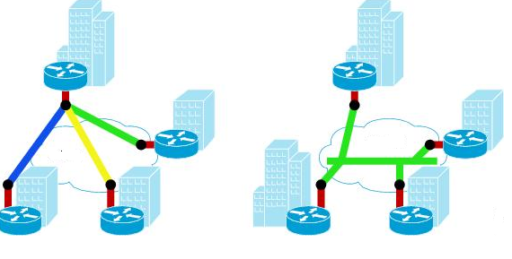

**Figure No. 6**

1. Refer to the exhibit shown in figure no.6. Which type of Metro E service do they represent? And differentiate between the two services. [3+3 marks]
2. What are the two most important benefit of using MPLS over other WAN services, explain each of them briefly. [4 marks]

## Question No. 4

1. Frame Relay is a layer 2 protocol. So does it use MAC address to forward frames? [3 marks]
2. Refer to figure no.7 below. Explain the last two commands. Why is there “ietf” in one command but not in the other? [5 marks]

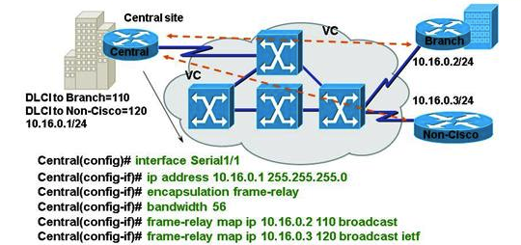

**Figure No. 7**

1. What are LMI used for? Name the available standards. [3 marks]

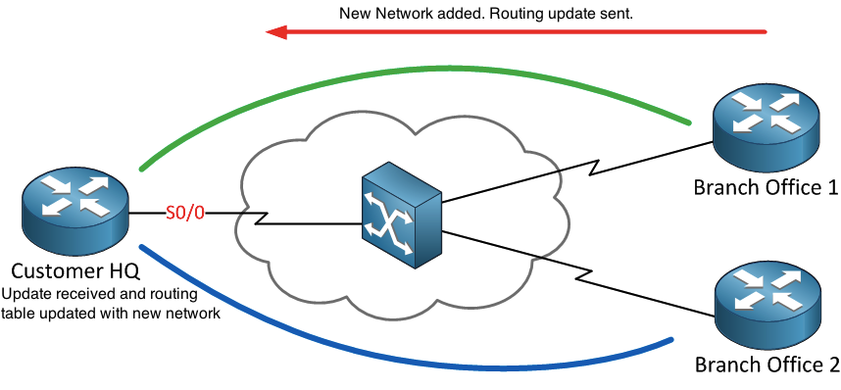

**Figure No. 8**

1. Refer to the above figure no.8. Customer HQ has two PVCs with its two branch offices. Now Branch Office 1 just added a new network 200.20.20.0/24 to its LAN connection, and then sends a routing update to Customer HQ. Then Customer HQ router updates its routing table with the new network. But after some time the administrator found out that Branch Office 2 did not receive any updates regarding the new network. Why and how can we solve it? [5 marks]

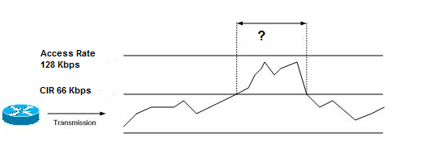

**Figure No. 9**

1. A company has a CIR of 64 Kbps for a frame relay connection as shown in the above figure no.9 . How will the frame relay switches handle the frames during the spike shown with a “?” mark? [4 marks]

## Question No. 5

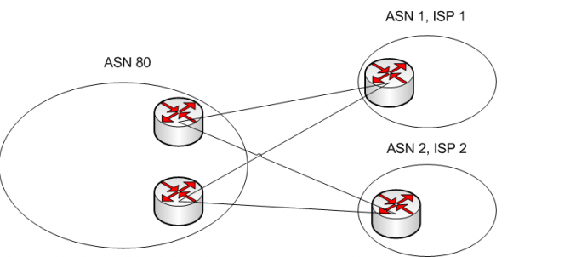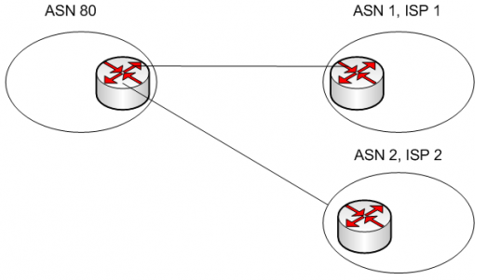

**Figure No. 11**

**Figure No. 10**

1. What kind of AS is shown in figure no.10 and figure no. 11? What is ASN80? [4+2 marks]

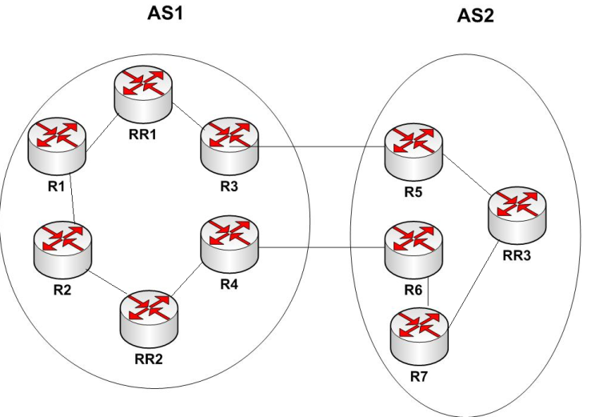

**Figure No. 12**

1. In figure no. 12, R2 wants to send some data to R7. Which border router will it choose R3 or R4, and why? [4 marks]
2. How is Inter AS routing different from Intra AS routing? [4 marks]
3. For BGP optimum path means ………….? [1.5 marks]
4. Refer to the figure no.13 below. An update is being propagated from AS1 via all the Ass until it reaches AS4. The rectangular boxes displays the information being sent in the updates. Explain what they are and which attributes they represent. [4.5 marks]

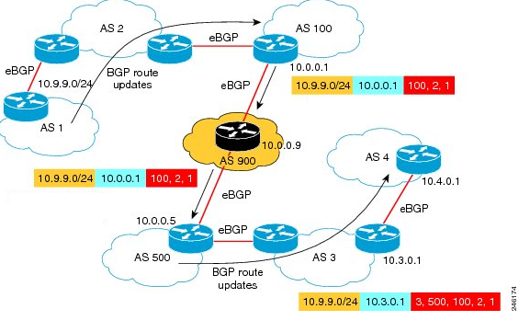

**Figure No. 13**

## 

## Question No. 6

1. What are the marking fields used in Layer 2 and Layer 3? [3 marks]
2. NBAR (Network Based Application Recognition) is a special type of classification. How does it help us and where do we use it? [4.5 marks]
3. Refer to the figure no. 14, this shows CBWFQ Round Robin Scheduling. Now this is not preferable for voice and video, why? And how do we solve it? [3+3.5 marks]



**Figure No. 14**

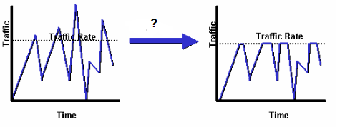

**Figure No. 15**

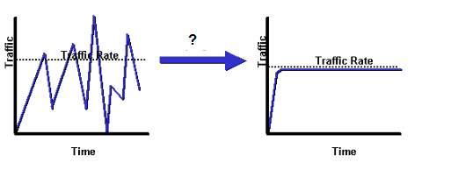

**Figure No. 16**

1. We know that policing and shaping is used to provide QoS. Which of the diagram shown in figure no. 15 and figure no.16 above represents policing and which represents shaping? Explain what is happening. [2+4 marks]

## Question No. 7

1. Differentiate between IaaS and PaaS. [3 marks]
2. **What are the benefits of connecting cloud with private WAN services?** [4 marks]
3. Your company runs are virtualized web app server in house. You decide to make the web applications available over Internet through a cloud provider. How should you do it, using which method and why? [5 marks]



**Figure No. 17**

1. Refer to figure no. 17. The company has decided to use Microsoft Exchange as a Saas service for their email servers. Right now the connectivity to the email servers are as shown. What is the problems associated with the current scenario and how can we solve it? [5 marks]
2. VMs and VNFs need to synchronize their time with other devices in the enterprise, how? [3 marks]

##### THE END